Cameron Lewis
CAP4611
Oct 7th 2025
5593788
Assignment 3
- Matrix Submission Format
  - Converting to Matrix/vector/Norm Notation
    - ${\left\|Xw-y\right\|}^{2}$
    - ${\left(Xw-y\right)}^{T}V\left(Xw-y\right)+\frac{λ}{2}w^{T}w$
    - ${\left\|Xw-y\right\|}_{∞}+\frac{1}{2}1^{T}A\left|w\right|$
  - Minimizing Quadratic Functions as Linear Systems
    - $w=v$
    - $\left(X^{T}X+A\right)w=X^{T}y$
    - $\left(X^{T}VX+λI\right)w=X^{T}Vy+λw^{0}$
- Robust Regression and Gradient Descent
  - Weighted Least Squares in One Dimension
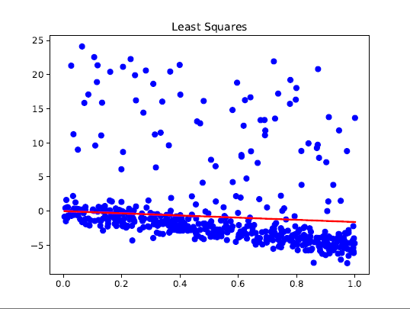
V = np.diag(v)
# Solve weighted normal equations
self.w = solve(X.T @ V @ X, X.T @ V @ y)

  - Smooth Approximation to the L1-Norm
    - $r_{i}=w^{T}x_{i}-y_{i}$
$f_{i}\left(w\right)=\log\left(\exp\left(r_{i}\right)\right)+exp⁡(-r_{i}$)
$\frac{df_{i}}{dw}=\frac{1}{\exp\left(r_{i}\right)+\exp\left(-r_{i}\right)}∙(\exp\left(r_{i}\right)-exp⁡(-r_{i})∙\frac{dr_{i}}{dw}$
$$=tanh⁡(r_{i})x_{i}$$
$∇f(w)=\sum_{i=1}^{n}{tanh(w^{T}x_{i}-y_{i}​)⋅x_{i}​}​$
  - Gradient Descent: Understanding the Code
    - alpha
    - g_old
    - self.parameters
    - checks whether the optimization should terminate by testing if the gradient norm is below tolerance or if the max number of evaluations has been reached
  - Robust Regression

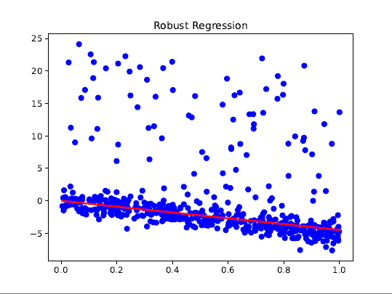
w = ensure_1d(w)
y = ensure_1d(y)
w = ensure_1d(w)
y = ensure_1d(y)
# Compute residuals
residuals = X @ w - y
# Compute function value using log-sum-exp
f = np.sum(np.log(np.exp(residuals) + np.exp(-residuals)))
# Compute gradient using tanh
g = X.T @ np.tanh(residuals)
return f, g

    - 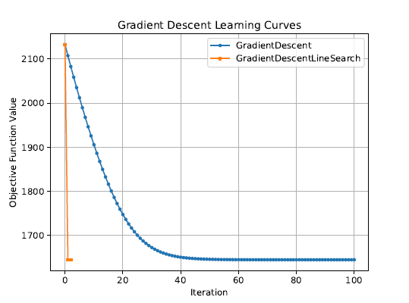
Line search seems to be efficient
- Linear Regression and Nonlinear Bases
  - Adding a Bias Variable
    - 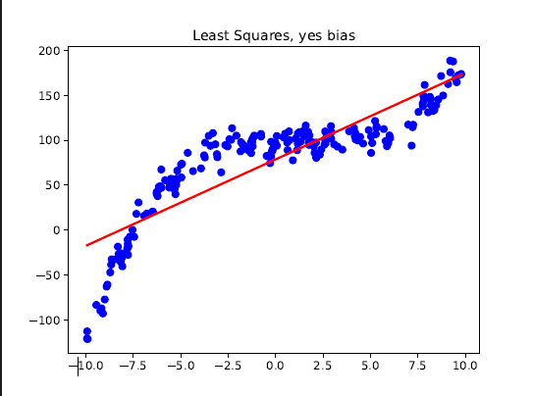

class LeastSquaresBias:
"Least Squares with a bias added"
def fit(self, X, y):
n = X.shape[0]
# Add column of ones to the left of X for bias term
X_bias = np.hstack([np.ones((n, 1)), X])
# Solve normal equations with augmented X
self.w = solve(X_bias.T @ X_bias, X_bias.T @ y)
def predict(self, X_pred):
n = X_pred.shape[0]
# Add column of ones to match training
X_bias = np.hstack([np.ones((n, 1)), X_pred])
return X_bias @ self.w

Training error = 938.4
Validation error = 844.4
  - Polynomial Basis
    - 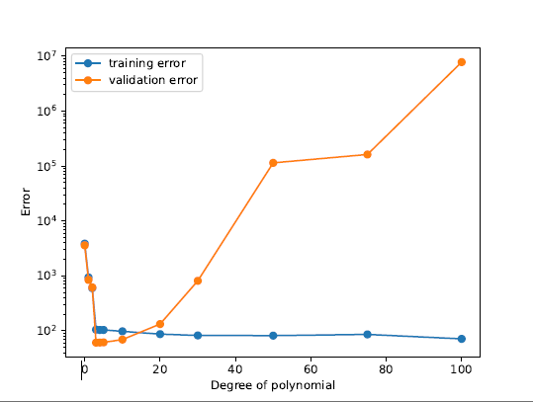
def fit(self, X, y):
Z = self._poly_basis(X)
# Fit least squares on transformed featureas
self.leastSquares.fit(Z, y)
def predict(self, X_pred):
Z_pred = self._poly_basis(X_pred)
# Predict using least squares model
return self.leastSquares.predict(Z_pred)
# A private helper function to transform any X with d=1 into
# the polynomial basis defined by this class at initialization.
# Returns the matrix Z that is the polynomial basis of X.
def _poly_basis(self, X):
n = X.shape[0]
# Initialize Z with appropriate size
Z = np.zeros((n, self.p + 1))
# Fill each column
for j in range(self.p + 1):
Z[:, j] = (X[:, 0] ** j)
return Z

As p increases, the training error decreases, meaning that higher-degree polynomials can fit the training data more closely, and the training error becomes very small.
- Very Short Answer Questions
  - K-means will assign it to the nearest cluster and density will label it as noise
  - K-means is initialization dependent, and random restarts can reduce bad starting points, but density-based is the same output every time so it doesn’t matter
  - Yes. Depending on how points are linked it can form long irregular cluster shapes
  - Fit a Gaussian bell curve to data and the problem is the data wont follow the gaussian shape
  - KNN graph with outliers being points with few neighbors or far distances, and the problem is that the result will be heavily dependent on k
  - Train a classifier on normal and abnormal data. The problem is that it needs labeled examples of outlier types
  - It would not make sense since gradient descent is better used for large datasets
  - The column lets the model learn an intercept and decision trees do not need this
  - We still need gradient descent because of the loss function
  - Too small the algorithm learns to slowly and when its too large it jumps around too much
  - It allows us to compute gradients and use gradient descent effectively by making sharp non smooth functions smooth
  - Use sin and cos for different values of k to capture patterns in the data.

